**Module 5**

Andrew Siekmann

Colorado State University Global

CSC 500-1 Principles of Programming

Lori Farr

3/13/2024

**Pseudocode:**

Months = #list of months

Rainfall = []

Number of months =0

Total inches =0

Years = user input

For i in range(0, years)

For month in months:

Append input of inches for month

Number of months +=1

For rain in rainfall

Total inches += int(rain)

Avg inches = total inches / len(rainfall)

Print number of years

Print number of months

Print total rainfall

Print avg rainfall

**Figure 1**

**Code, Execution, Output Part 1**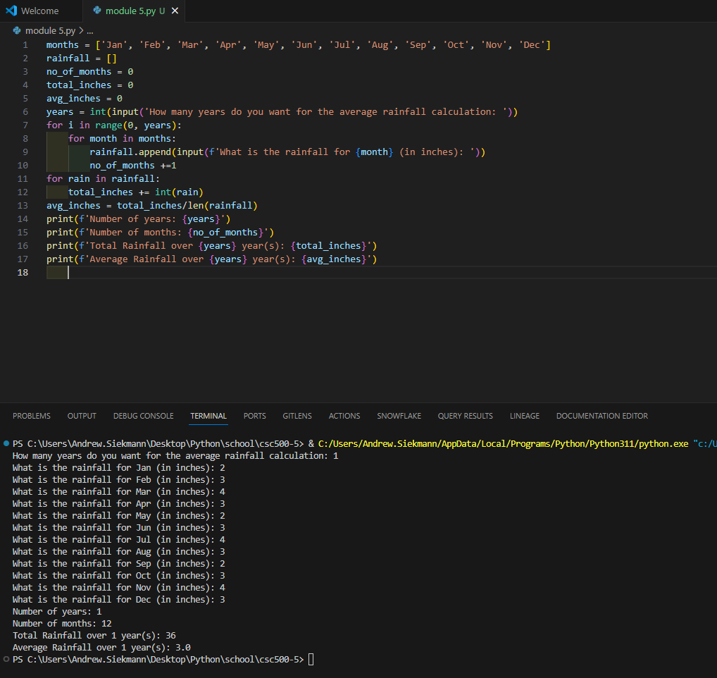

**Pseudocode pt 2:**

Number of books = user input

If number < 2

Print 0 points

Elif number < 4

Print 5 points

Elif number < 6

Print 15 points

Elif number < 8

Print 30 points

Else

Print 60 points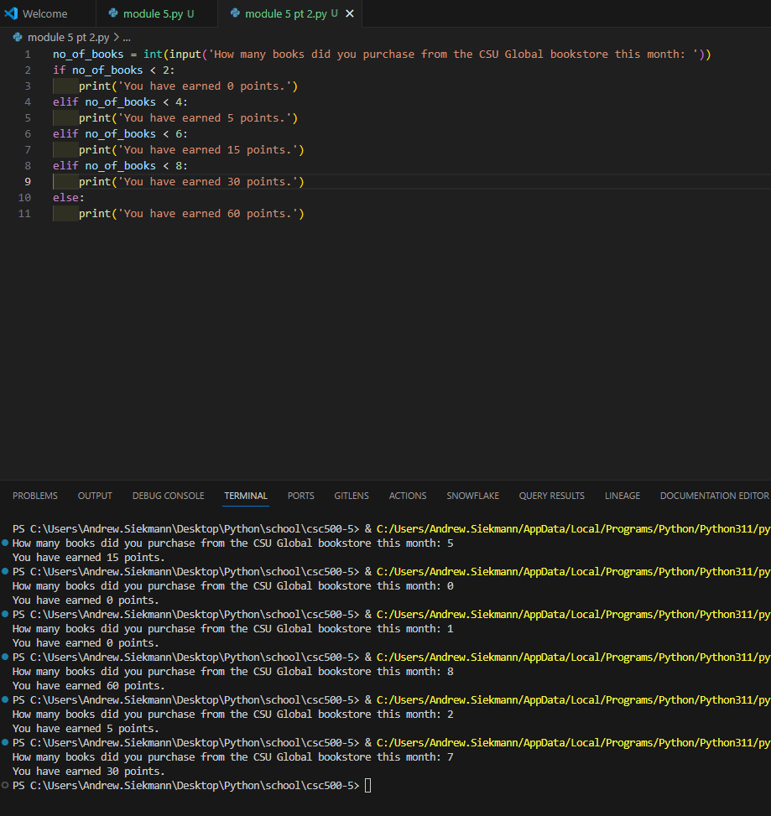

**Git Repository**

<https://github.com/siekmann-school/csc500-5>